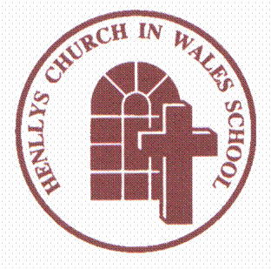

Professional Learning Grant Evaluation
It is a Welsh Assembly Government (WAG) requirement that we keep parents informed about the professional learning that takes place in school and our use of the professional learning grant.
Last year, Henllys Church in Wales School was given £3300 by WAG to spend on professional learning. We used this money to release teachers to take part in a variety of training linked to the new curriculum that is going to be statutory from September 2022.
Here are some examples of what we have been doing:
- The Headteacher attended training in the Excellence in Teaching and Leadership Framework.
- The DHT attended professional learning events with other schools from the cluster.
- Staff took part in a joint project with cluster schools on the new curriculum.
- Staff carried out a series of professional enquiries linked to improving outcomes of children in their classes.
This year we have been given £3365 for professional learning and we intend to use this money to continue to develop staff ready for the new curriculum. We plan to access leadership programmes to support middle leadership core development and release the Professional Learning Lead to attend cluster professional learning meetings and provide in school curriculum reform updates. Staff will also have more release time to enter into their own research in order to further improve the provision for the children.
If you require any further information please contact the school.

Mrs Philippa Minto
Headteacher

