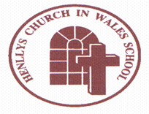
Henllys Church in Wales School

Pupil Deprivation Grant Plan

2021/2022

It is a Welsh Government requirement that the school make you aware of the way in which we use our Pupil Deprivation Grant. This is a grant that is targeted at supporting pupils who are eligible for free school meals (this being used as a measure of deprivation).

This school currently has a school roll of 176 pupils of which 19 (11%) are eligible for free school meals. This generates a Pupil Deprivation Grant of £16,100 and an Early Years Pupil Deprivation Grant of £1150. The grant is used to offset the cost of additional staffing to support our most vulnerable learners.

The school currently undertakes the following activities in order to support pupils facing the challenges of poverty and deprivation:

- Teach Your Monster to Read
- Nessy
- Springboard Maths
- Number Recovery
- Corrective Reading
- Catch Up Literacy
- Pastoral Support from a Trauma Informed Schools lead
- ComIT small group support

As a result, our FSM pupils perform well with a majority of pupils working at ‘at least’ the expected level for their age throughout the school. A few are working above the expected age.

Growing and Learning Together Through the Love of Christ

