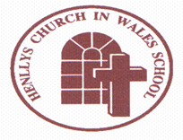
Henllys Church in Wales School

Professional Learning Grant Plan

2021/2022

It is a Welsh Assembly Government (WAG) requirement that we keep parents informed about the professional learning that takes place in school and our use of the professional learning grant.
This year, Henllys Church in Wales School has been given £4027 to spend on professional learning. We have used this money to release teachers to take part in a variety of training linked to their professional development, ALN reform and the implementation of the new curriculum which becomes statutory from September 2022.
Here are some examples of what we have been doing:
- One member of staff is undertaking a Senior Leaders Programme.
- One member of staff is undertaking a Middle Leaders Programme.
- Areas of Learning an Experiences Team Leaders are attending network meetings,
- Whole school training on Maths and Numeracy in the new curriculum.
- Staff training on a ‘Whole school approach to Wellbeing’.
- Two Teaching Assistants have completed the HLTA course.
- ALNCo has attended training on ALN reform and the ALN bill.

If you require any further information, please contact the school.

Growing and Learning Together Through the Love of Christ

