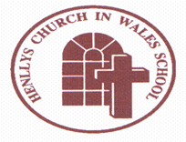
Henllys Church in Wales School

Recruit, Recover, Raise Standards Grant Plan

2021/2022

It is a Welsh Government requirement that the school make you aware of the way in which we use our Recruit, Recover, Raise Standards Grant. This is a grant that is targeted at supporting pupils as they seek to get back on track after the interruptions in their education due to Covid-19 pandemic.
Henllys Church in Wales School has been given £7,138 to spend on additional human resources. We have used this money to release our HLTA and a TA to deliver targeted intervention to support some of our Additional Learning Needs pupils.
Here are some examples of what we have been doing:
- Small group phonics intervention in Reception.
- Corrective Reading for pupils in Y2 /Y3.
- Catch Up Literacy for pupils in Y2/Y3.
- Spelling intervention using Nessy.

The intervention has clearly had an impact and learners are beginning to close the gaps between their reading/spelling ages and their chronological ages.
If you require any further information, please contact the school.

Growing and Learning Together Through the Love of Christ

