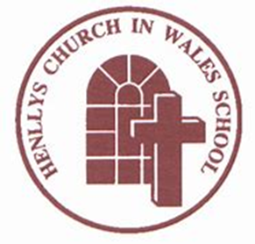

Henllys Church in Wales School

Teaching and Learning Policy
DRAFT

Growing and Learning Together through the Love of Christ
At Henllys Church in Wales School, we pride ourselves in providing a very kind and nurturing environment for all our learners and we really feel that we are one big happy family. Community spirit is a real strength of ours, which we hope is echoed in our ethos, mission statement and school vision which are as follows:

Our Ethos:
‘Growing and Learning Together through the Love of Christ’.
As a school, we all want to grow and learn together.
Our Vision:
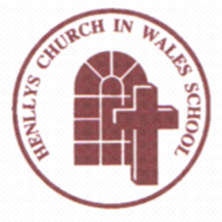 Inspire
Challenge
Achieve
Nurture
We want to inspire a new generation to ‘achieve’ and reach their full potential. ‘I CAN’ is something that we encourage all pupils to say rather than ‘I CAN’T’.
Our Vision Statement:
The following statement reflects what we firmly believe the children of Henllys Church in Wales School will become in the future:
‘Our vision is to provide an outstanding education, rooted in the Christian faith and values, where all learners are able to reach their full potential. Our children will become ethically informed citizens, who really care about the world around them. They will be active individuals, prepared to lead fulfilled and healthy lives.
With confidence and ambition, they CAN and will succeed!’

As a Church in Wales School, we will still be maintaining our ethos ‘Growing and learning together through the Love of Christ’ as this underpins every activity we undertake. We pray and worship together, as a school community, and exemplify these Christian Values in all that we do:

Respect, Peace, Compassion, Courage, Justice, Thankfulness, Trust, Humility, Truthfulness, Perseverance, Forgiveness and Responsibility.

We respect each other and help each other in our class work, play time and relationships. We always listen to each other, embracing our similarities and differences and celebrate ‘Following in Jesus’ Footsteps.’

Purpose of the Policy
The purpose of this policy is to outline what our pupils, staff, governors and parents really value in the education we provide for all our learners. It has been written taking into account all stakeholders’ views, and it reflects what we all feel is important in the areas of teaching and learning and highlights a common understanding of curriculum design.
Aims of the Policy
- To provide an agreed focus for planning and developing teaching and learning.
- To build the capacity of all leaders, practitioners and learners by encouraging the sharing of good practice.
- To improved standards of teaching and learning across all areas of the curriculum.
- To collectively reflect upon and develop our pedagogical approaches to build capacity across the school.
- To improve the quality of learning experiences provided for the children and to enable staff to identify areas for development.

Aims of Teaching
- Be directed to achieving the four purposes.
- Apply the 12 pedagogical principles identified when planning teaching and learning.
- Provide children and young people with the opportunities to learn from expertise and experience from inside and outside the school.
- Create authentic learning contexts within which learners can demonstrate the ability to apply learning independently.
- Promote a shared understanding of criteria which underpin good teaching and learning.
- Ensure that children have opportunities to develop their Literacy and Numeracy skills, Digital competency and Welsh language.

Aims of Learning
- To ensure that the four purposes are at the heart of all Areas of Learning and
Experiences.
- To create an authentic context for learning in which pupils have opportunities to reinforce and consolidate cross-curricular responsibilities, including Literacy, Numeracy and Digital Competence.
- To encourage children and young people to take increasing responsibility for their own learning and to equip them with the skills required to participate successfully and confidently in the modern world.
- To support social and emotional development and positive relationships.
- To encourage collaboration and independence to ensure progression.

Curriculum Design

At Henllys C.I.W. School we aim to provide a caring, supportive and stimulating safe environment with high quality teaching to develop our pupils as:

- Ambitious, capable learners, ready to learn throughout their lives,
- Enterprising, creative contributors, ready to play a full part in life and work,
- Ethical, informed citizens of Wales and the world,
- Healthy, confident individuals, ready to lead fulfilling lives as valued members of society.
These are the four purposes which we refer to as Ambitious Aled, Enterprising Ellen, Ethical Elinor and Healthy Huw.
The 12 pedagogical principles outlined below, underpin all our teaching and learning. ‘Decisions about teaching and learning are very context based and purpose specific and are best taken by the teachers themselves.’
(Successful Futures Report by Professor Donaldson)
Curriculum for Wales offers a broad and balanced structure and our curriculum design must comprise of six Areas of Learning and Experience which are:
• Expressive Arts
• Health & Well-being
• Humanities
• Languages, Literacy and Communication
• Mathematics and Numeracy
• Science and Technology

Each AoLE will have an additional overview to accompany this policy which outlines the specific nature and essence of each of the above. We agree to adopt topic or ‘theme based’ approaches which incorporate ‘hooks or immersion days’ followed by a midpoint review to further enhance the learning. At the end of each topic or theme there should be a celebration event.

All teaching and learning will promote progression in the three cross curricular responsibilities of Literacy, Numeracy and Digital Competence.

Our curriculum design will also incorporate, where appropriate, opportunities for learning of cross-cutting elements. These should allow learners to:
- consider local, national and international contexts
- develop understanding of relationships and sexuality education, human rights education and diversity, and careers and work-related experiences

Agreed Teaching and Learning Styles at Henllys C.I.W. School

Pupils at Henllys believe that good teaching and learning is when:

- It’s fun and engaging.
- It covers a range of subjects.
- We get involved and make decisions.
- We work together.
- We learn outdoors.
- We are challenged.

Staff have agreed to incorporate the following into their teaching:

- Actively encourage Pupil Voice to engage interest.
- Build positive relationships and provide a positive and safe environment.
- Enable learners to build connections across their learning.
- Allow learners to make sense of growing up in Wales.
- Explore and revisit concepts to develop a deeper understanding.
- Be suitable and appropriate for different ages and abilities.
- Move the learning forward.
- Stimulate and challenge learners.
- Offer breadth and depth of learning experiences.
- Incorporate learning outside the classroom.
- Include multisensory experiential learning and practical activities e.g. hands on activities, learning through play and games both in the classroom and outdoors.
- Raise aspirations and teach diversity.
- Develop Welsh language and bilingualism.
- Be collaborative and use a range of pupil groupings.
- Challenge all learners and recognise the importance of sustained effort.
- Promote problem solving, creative and critical thinking.
- Set tasks and select resources that build on previous knowledge and experience and engage interest.
- Use balance of direct teaching and rich learning experiences.
- A good pace to engage learners but allow sufficient ‘thinking time.’
- Set high expectations by using strategies such as modelling and WAGOLL.
- Treat, respect and value pupils as individuals.
- Provide regular positive feedback - oral/written comments and next steps in learning.
- Incorporate a range of Assessment for Learning strategies based on the following model.

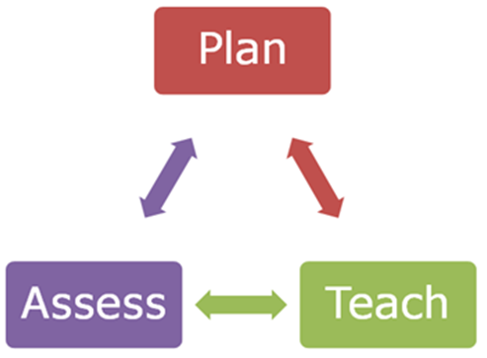

The Learning Environment

At Henllys we will ensure that the learning environment incorporates these qualities:

1. Creates an atmosphere which is safe, positive and welcoming.
2. Well-organised, clean, tidy and stimulating.
3. Well-resourced and easily accessible to all pupils.
4. Attractive displays which reflect current work and the curriculum.
5. Proud boards to ensure all learners have good quality work on display.
6. Layout of furniture gives pupils as much ‘work space’ as possible.
7. Provides flexibility between individual, paired, group work and whole class.
8. Promotes positive behaviour.
9. Effective use of ICT equipment.
10. Promotes bilingualism, numeracy, literacy and digital competence.

Additional Learning Needs

Reasonable Adjustments are essential foundations of teaching, assessment and intervention for all pupils and at Henllys reasonable adjustments:

- seek to engage and support the learning of ALL children.
- build on pupils’ prior learning and responds appropriately to their voice.
- build from the skilful design of learning as children progress at their own pace.
- involves a curriculum that is methodically constructed and renewed to deliver small and efficient steps of progression.

Universal Provision is an assessment and intervention process which is co-ordinated by the ALNCo, working alongside other school staff. Universal provision ensures that learning environments are tailored to meet the needs of all children so they are able to make progress in learning and wellbeing.

Targeted Intervention will be additional to those provided through reasonable adjustments and classroom support. Professionals with appropriate knowledge and skills will work with children to monitor the specific needs and act accordingly if additional help is needed.

Specific Intervention will be required when a child has complex needs which means in order to meet need and make progress specific/specialised individualised provision is required. The school will seek advice and support from other agencies to help with assessment and intervention for these pupils.

