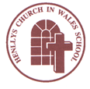
Growing and Learning Together Through the Love of Christ

Henllys Church in Wales (Voluntary Aided) School

Governors' Annual Report to Parents 2021-22

COMPOSITION OF THE GOVERNING BODY

Name of Governor | Type | Office Expires
Revd Elizabeth Kerl | CoG  Foundation  Governor | 8.03.2024
Revd Nick Perry | Vice Chair | Ex Officio
Philippa Minto | Headteacher | N/A
Keiron Jones | Foundation | 16.06.2023
Rhiannon Fisher | Foundation | 25.04.2025
Jean Geary | Foundation | 25.04.2026
Ceri-Ann Jones | Foundation | 18.10.2025
Karen Horan | Foundation | 27.05.2025
Honor Hollister | Foundation | 25.04.2026
Louise Sulway | Teacher | 18.09.2024
Hilary Croft | Staff | 05.02.2024
Francis English | LA | 08.07.2022  Re-elected
Claire Matthews | Parent | Resigned
Keith Johnson | Minor Authority | 31.05.2023
Vacancy | Foundation | tbd

Clerk to the Governors
Callum Roberts - Governor Support Officer from the Education Achievement Service (governor.support@sewaleseas.org.uk).

Governors Functions
At each A.G.M., governors are elected to the committees listed below:

1. Recruitment and Resources Committee
2. Staff Disciplinary and Dismissal Committee
3. Staff Disciplinary and Dismissal Appeals Committee
4. Performance and Improvement Committee
5. Pupil Discipline and Exclusions Committee
6. Grievance, Performance Management and Pay Appeals Committee

The Governing Body of the school meets twice every Autumn and Summer term and once every Spring term. Other committees meet as required, prior to every full meeting.

The governors are great supporters of the school and their time is greatly appreciated. They are always welcome at any events that take place in the school and they also attend courses laid on by the Education Achievement Service. Depending on their roles, governors also attend self-evaluation activities. The Chair of the Governing Body can be contacted via the school.

STAFFING

Classroom organisation for 2021/22 was as follows:

Mrs. Henson/Mrs. Evans Reception
Miss Needle Year 1
Mrs. Sulway Year 2
Miss Baldwin Year 3
Mr. Yendle Year 4
Miss Bevan Year 5
Mrs. Llewellyn Year 6

Support staff in the school during 2021 – 2022:

HLTAs: Mrs. Cook, Mrs. Meehan & Mr. Barton
Classroom Miss Kent (cover supervisor)
Assistants Mrs. Meehan
Mrs. Davies
Mrs. Chambers
Mr. Barton
Mr. Smith
Mrs. Gunningham
(3 days per week)
The school operates with the services of a clerk, caretaker, two cleaners and four midday supervisors. School meals are provided by Torfaen Catering. Meals are produced by a cook, an assistant cook and one kitchen assistant.

SESSION TIMES
Session | Times
Morning Session | 8:50 to 12:15
Worship | 10:30 to 10:45
Morning Playtime | 10:45 to 11:00
Lunch Time | 12:15 to 13:15
Afternoon Session | 13:15 to 15:15
N.B. Term dates are outlined at the end of this report.

COMMUNITY AND CHURCH LINKS
There are good opportunities for pupils to learn about their local community. All pupils support the Friends of Henllys L.N.R. to complete specific projects to develop our Local Nature Reserve e.g. apple picking. Our Year 3/4 pupils also became involved in a school based moth project run by the Friends of Henllys L.N.R.

Attendance at community events during and after school, was hampered again by Covid restrictions this year. However, pupils accessed a range of ‘virtual’ activities such as the Keep Me Safe partnerships with the local police. Year 6 were able to attend Crucial Crew and pupils in KS2 took part in a range of STEM workshops.

Members of the local community worship at the school every Sunday and within the wider community, Reverend Kerl and some of the Benefice Lay Readers are regular visitors to the school giving valuable assistance with collective worship. In December 2021, thirty-three Year 6 pupils completed confirmation classes and ten of them were confirmed in a special Confirmation Service at St. Gabriel’s Church on the 9th December 2021. Twenty-one Year 2 pupils also attended Baptism classes and six pupils were Baptised in the Worship centre on Tuesday 14th June 2022.

Confirmation Service at St. Gabriel’s Church
The school also took part in a range of special Worships throughout the year i.e. Remembrance Day Service, Christmas Service, St, David’s Day Eucharist, Ash Wednesday, ‘shadow’ Holy Week including Palm Sunday and an end of year church service at St. Gabriel’s.

The whole school also contributed to a new world record for the most videos uploaded to social media in one hour on Tuesday 25th January 2022 (St. Dwynwen’s) by recording and uploading renditions of Hei Mistar Urdd.

Our Year 5/6 pupils recorded three songs for the Cwmbran Community Council Choral Festival which was aired on Wednesday 9th March 2022.

Pupils entered a Foster Wales competition to design sunflowers and we had two winners from our school – Caitlin in Year 5 and Adam in Year 2.

LINKS WITH OTHER SCHOOLS
Staff maintained links with other schools by attending a range of cluster network meetings. Our Year 6 pupils undertook a science and technology cluster project linked to our Summer Term topic ‘Survival of the Fittest’. On Monday 13th June 2022 we had a visit from some Curriculum Champions from St. Alban’s who came to Henllys to speak to our pupils about the new curriculum. They were very impressed with the wide range of Assessment for Learning strategies which were clearly evident across the whole school.
The Headteacher also supported a school in another local authority as part of her School Improvement Partner role.

The school is proud to have become a Learning Network School for Assessment for Learning and Curriculum Design.

EXTRA-CURRICULAR ACTIVITIES
The school ran a broad range of extra-curricular activities throughout the year which were as follows:
Netball, football, rugby, hockey, summer sports, multi-sports, creative arts, sing & sign, choir, eco/gardening club and homework/traditional games. These clubs were very well attended.

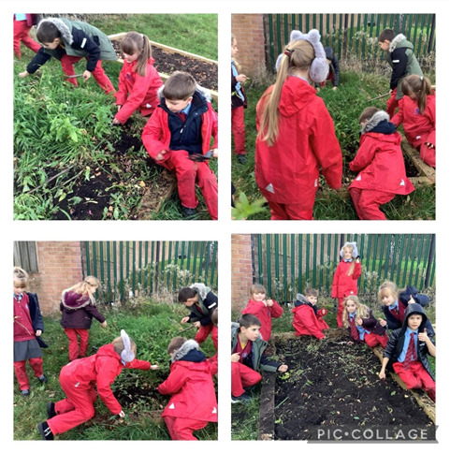
Eco-Club Clearing our Flower Beds

TRIPS, VISITS & CELEBRATIONS
Our Year 3 and Year 4 classes went to the Roman Museum in Caerleon and also took part in a Roman Boot Camp. Our Y5 and Y6 classes went to a World War II experience in Monmouth. Our Reception class went to visit St. Gabriel’s Church and we attended special end of year Leavers’ Services in St. Woolos Cathedral and St. Gabriel’s Church.
On Friday 10th June 2022 the whole school went to Bristol Zoo for the day prior to its closure.

On Friday 27th May 2022, we held a very special Platinum Jubilee Tea Party to celebrate the Queen’s Platinum Jubilee. Each class dressed up according to a decade the Queen had reigned for so Reception were 2010s, Year 1 2000s, Year 2 1990s, Year 3 1980s, Year 4 1970s, Year 5 1960s and Year 6 1950s.

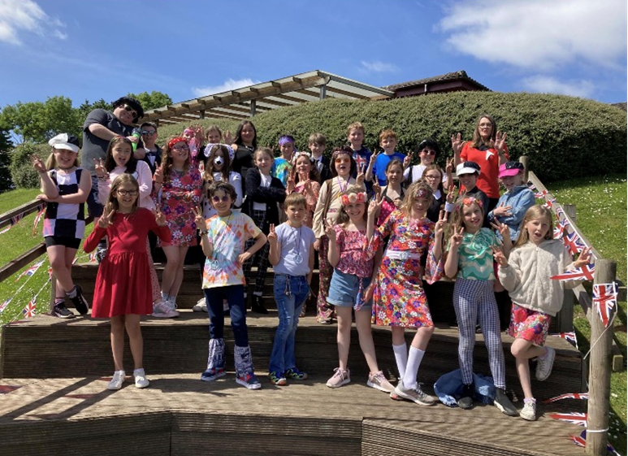

Blwyddyn 5 dressed up 1960s style.

SUPPORTING CHARITIES
The school took part in a number of fund raising activities including:

Donating Harvest food parcels for Eastern Valley
McMillan Coffee Morning Cake Sale
Children in Need
Poppy Appeal
Schwmae Su’mae day
Elf Day
Ukrainian Appeal
Comic Relief Day

SPORT/EXERCISE
Sport and fitness is high on our agenda and we ensured that pupils undertook daily exercise in the form of a ‘daily mile’ this year. Torfaen Sports Development Team ran a course of dance lessons in our Year 4 class. Our Year 5 pupils also successfully completed the Playmakers course during the Autumn Term and Torfaen’s Safe Cycling course during the summer term.

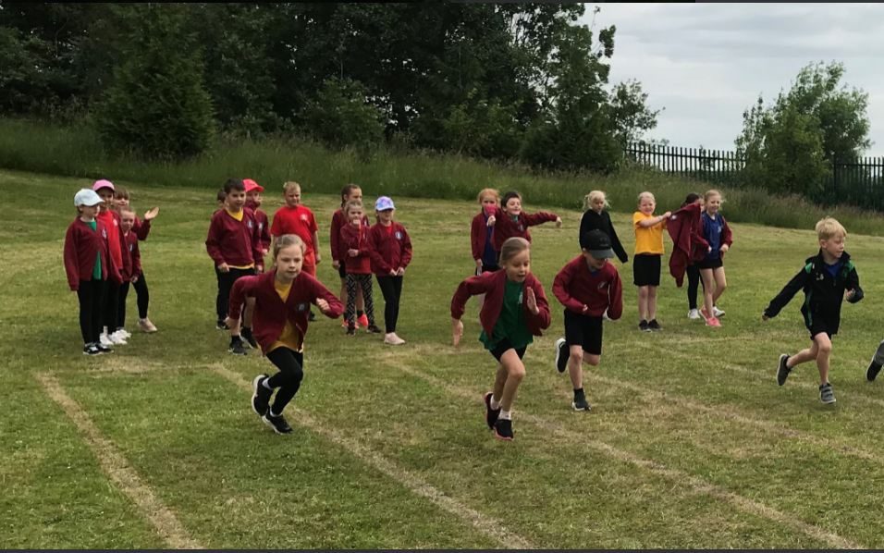

We held a well-attended Sports Day on Wednesday 15th June 2021 which all pupils took part in. This also formed part of our Healthy Schools week.

A broad range of teams took part in a wide variety of tournaments throughout the year. Our netball, rugby and football teams entered the Urdd tournaments with our netball team reaching the semi-final and our rugby team reaching the quarter final. Our girls’ football team got to the semi-final of Torfaen’s football tournament too. Our tennis team won Torfaen’s tennis tournament held in Pontypool Park. For the first time, our hockey team also competed in a local hockey tournament and played really especially as some players were only in Years 3 and 4 and were against much older children.

Three pupils successfully got selected for Pontypool U11s District Rugby Team and competed and won an international tournament in Italy. Two of these pupils played in the final of the D.C. Thomas Cup on the 27th April 2022 at the Principality Stadium and actually won the cup to the delight of the Year 5 and Year 6 pupils who went down to the stadium to support the boys!

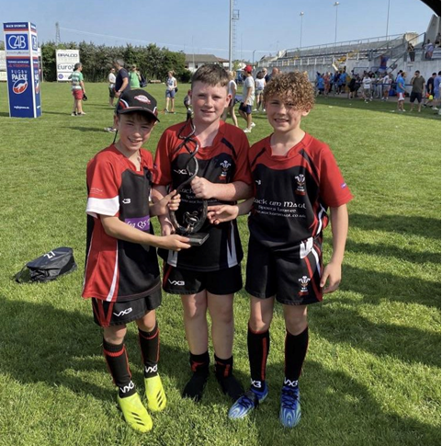

Tom S., Noah S. and Noah M. representing Pontypool Rugby District.

TRANSITION
Transition links are very good with St. Alban’s R.C. High School. As a result, pupils who transfer to St. Alban’s settle in well and make good progress. There are regular cluster meetings involving the primary schools and St. Alban’s staff. The topics include professional learning, planning for the new curriculum, and additional learning needs provision and training. Year 6 pupils completed a science transition project during the summer term too.

ALN pupils are given access to enhanced transition opportunities so that the receiving school is more able to meet their needs effectively.

Y6 leavers went to the following schools:
St. Alban’s R.C. High School 25
Cwmbran High School 6
Croesyceiliog 2
West Mon. High School 1
Total 34 pupils

ADDITIONAL LEARNING NEEDS and LOOKED AFTER CHILDREN
We try to identify children with Additional Learning Needs (ALN) as soon as they enter the school. Good communication between Reception and pre-school facilities mean that we often gain information about children before they start at Henllys. This process gives the children the best start to school life, as we are able to meet individual needs as soon as possible. Close working with outside agencies, including the Educational Psychologist and Outreach, increases the support we can offer to children as they move through the school. Every class has additional support for the children in each year group. This support is directly proportional to the level of need of the children in each particular class. Progress of ALN/ LAC children is measured through our usual testing and assessment arrangements as well as a review of their specific targets on a termly basis. ALN children are given One Page Profiles with specific and measurable targets which are worked on regularly in class as much as possible and sometimes through withdrawal groups.

We offer a broad range of intervention programmes for literacy and numeracy, as well as pastoral support for the emotional wellbeing of our children. Some children receive support from peripatetic teachers and some children are allocated a teaching assistant to work with them in small groups. LAC children are given extra support where appropriate and this year grant funding was used to fund a Wellbeing Dog from Caring Canines who visited the school every Tuesday afternoon.

PUPIL DEPRIVATION GRANT 2021/2022
It is a Welsh Government requirement that the school make you aware of the way in which we use our Pupil Deprivation Grant. This is a grant that is targeted at supporting pupils who are eligible for free school meals (this being used as a measure of deprivation).

The school has a school roll of 177 pupils of which (10.2%) are eligible for free school meals. This generates a PDG grant of £16,100 and an EYPDG grant of £1150 which is used to offset the cost of additional staffing.

The school currently undertakes the following activities in order to support pupils facing the challenges of poverty and deprivation:

Homework Club
Teach Your Monster to Read
Nessy
Springboard/Spotlight Maths
Number Recovery
Corrective Reading
Catch Up Literacy
CoMIT social skills
Pastoral support
Small group support for phonics and reading.

As a result, FSM pupils perform well with many pupils achieving their end of year targets in all the core subjects. A majority of FSM pupils are working at ‘at least’ the expected level for their age throughout the school. A few are working above the expected age.

SCHOOL DEVELOPMENT PLAN
Our priorities for School Development in 2021/22 have been:

Whole School
- Develop outdoor learning in FP and KS2 to provide an exciting curriculum that challenges and inspires pupils and links effectively to the LNF.
- Develop an outdoor Sacred Space.
- Continue to roll out a wider range of AfL strategies.
- Ensure eFSM and MAT pupils progress in line with the rest of the school (develop provision for eFSM and MAT pupils).
- Re-establish closer links with other the Church, other schools (collaboration) and the local community post Covid-19.
- Re-establish pupil voice groups and ensure they contribute effectively to self-evaluation.
- Continue to develop senior and middle leaders e.g. Foundation Phase Leader, SLT members and Areas of Learning Team Leaders.
- Further develop TAs e.g. HLTA programme and relevant intervention training.
- Review Performance Management procedures to take account of the new Professional Standards.
- Re-establish professional enquiries and innovation post Covid-19.
- Continue to use the ETLF to improve the quality of teaching and learning.
- Embed ALN reform bill and new procedures.
- Continue with blended learning in light of Covid-19.

LLC:
- Improve performance in reading and spelling tests (national and GL).
- Improve phonics progress in FP.
- Improve handwriting e,g, letter formation in Reception to cursive handwriting in UKS2.
- Develop pupils’ ability to spell age appropriate words correctly.
- Narrow the gap between performance in reading and writing at the end of KS2 and FP.
- Further develop Welsh skills in UKS2 and revise language patterns post Covid using placemats and Cerdyn Clonc.
- Develop the role of the Helpwr Heddiw and the use of incidental Welsh to initiate conversations.

Maths/Numeracy:
- Training for implementation of the new curriculum (Team leader and staff).
- Improve performance in the procedural and reasoning tests and continue to develop reasoning skills.
- Continue to develop maths intervention in FP and KS2.
- Use Seesaw to effectively evidence numeracy skills in FP.
- Use the maths trackers effectively to plan maths/numeracy lessons and ensure appropriate differentiation and challenge.

Health and Well-being:
- Continue to improve provision for health and wellbeing.
- Embed Whole School Approach to Wellbeing, Trauma Informed Schools and Mindfulness provision.
- Re-establish the Wellbeing Warriors.

Science and Technology
- Use ICT baseline and skills ladder to measure progress.
- Update ICT provision i.e. chrome books and the use of Google classrooms in KS2.
- Use Seesaw to effectively evidence science skills in FP.
- Use STEM activities to raise standards in science.

WELSH LANGUAGE
Henllys is an English medium school and as a result the main language used is English. However, we are proud of our Welsh heritage and try to ensure that children are given the opportunity to learn Welsh in daily short burst sessions and weekly hour long lessons appropriate to their age and ability. Our Helpwr Heddiw pupils lead the daily Welsh revision of language pattern and pupils are encouraged to use Welsh in other lessons and around the school too. Year 5 pupils undertook training from the Urdd to encourage playing games in Welsh at lunchtimes too. We celebrate the Welsh culture as much as possible through the curriculum, our Eisteddfod and through membership of the Urdd.

SCHOOL BUILDING AND YARDS
We are fortunate to have good facilities both internally and externally and the building and its surroundings, including toilet facilities, are in good repair. The inside of the school, including the toilets, are cleaned daily to ensure that the school environment is safe and hygienic for the children. This year we have upgraded the boiler system and underfloor heating and resurfaced the Junior Yard. It has also been painted with a compass, netball court and safe cycling route.

POLICY REVIEW
The following policies have been reviewed and adopted by the Governing Body in 2021/2022:

Safeguarding, Health and Safety, Teaching and Learning, Visitors and the LA’s Education Visits, Model Pay, Performance Management, CCTV, Social Media, Anti-Bullying, Lettings, Retention, Retention Procedures, Request for Information Procedures, Information/Data Loss Policy, Subject Access Request Procedures and Data Protection Policy.

Strategic Equality Plan
The school revisited its Strategic Equality Plan and agreed the following objectives:
Equality Objective 1
Children with any disability feel included and are an active part of their community and school.

Equality Objective 2
To continue to raise the attainment of vulnerable groups of learners (FSM, LAC, ALN and MAT).

Equality Objective 3
To consistently and robustly respond to bullying, racism, discrimination and harassment, both with regards to the victim and the perpetrator.

Equality Objective 4
To ensure that our pupils are listened to and influence decision making within the school.

Equality Objective 5
To provide a happy, safe and inclusive environment with pupil health and well-being at the heart of learning, creativity and play.

HEALTHY EATING
The school is in the process of going for Phase 6 of the Healthy Schools Award. We encourage healthy eating and drinking through fruit snack time and the salad bar at lunchtime and water is available in every classroom. The children are taught about healthy eating and drinking through the curriculum. School Council help to promote healthy eating and drinking and have written to parents requesting that only healthy snacks be brought into school. In June, the whole school took part in Healthy Schools Week which included a lot of opportunities for the pupils to learn about how to lead a healthy lifestyle. Healthy Huw is one of our Four Purposes Characters and forms an integral part of our provision.

RATES OF AUTHORISED AND UNAUTHORISED ABSENCES
Due to Covid-19, we are not required to report on targets in relation to absence for the 2021/22 academic year or set them for the 2022/23 academic year. However, Estyn asked us to improve our attendance and we will continue to monitor absences and contact parents when we have concerns about any pupil’s attendance. Parents can support us by not taking holidays during term time. A letter was sent to all parents reminding them of this in July 2022.
Attendance for 2021/22
 | Attendance  % | Total absence % | % days missed - unauthorised | % days missed - authorised
2021/2022 | 93.33% | 6.67% | 1.72% | 4.95%

SCHOOL PERFORMANCE
Due to Covid-19, there is no school performance data to report this year,

FRIENDS OF HENLLYS P.T.A.
Friends of Henllys P.T.A. has worked tirelessly to raise money for the school this year. Here are the committee members:

Chair: Chantel Roberts
Vice Chair: Vicki Parry and Katie Hackwood
Treasurer: Tiffany Furness
Secretary: Richard Barton

The Governors would like to thank the Friends of Henllys P.T.A. for all their hard work during the year in raising a large amount of money for the school. Thank you to the parents, families and friends for supporting the various activities that took place during the year. These included:

- Christmas Raffle
- Christmas Card Designs
- Elf Day
- Valentine Roses Sale
- Mothering Sunday Sale
- Grow a Pound Challenge
- Nifty Thrifty School Uniform Donation
- P.T A. disco
- Fathers’ Day Sale

Grow a Pound Challenge Winners 2022

This year, the P.T.A. has kindly funded the purchase of canvas boards to go up in our hall/Worship Centre. The boards are in the process of being designed and painted to form part of an Understanding Christianity ‘big frieze.’ The P.T.A. also funded Christmas parties, new books for all the pupils and a school disco. Much of the funds raised so far are going to be used to replace our outdoor play equipment.

HEALTH AND SAFETY
A variety of Risk Assessments relating to Covid were written and regularly reviewed this year. An Unauthorised Access To Roofs Risk Assessment was also carried out. The Headteacher, temporary caretaker and link governor also carried out a successful Health and Safety Audit.

No cars are allowed on site after 8:30 am and before 3:30 pm. This ensures the safety of the children at the beginning and the end of each day. Parents are reminded regularly that cars are not allowed to enter the grounds for health and safety reasons.

TCBC INTERNAL AUDIT
A thorough internal audit was carried out by Torfaen County Borough Council. The objective of the audit was to evaluate the adequacy and effectiveness of controls in responding to risk with the schools governance, operations and information systems. The audit was very positive and returned ten medium priority recommendations which are all being considered in full.

DISABLED PUPILS
The school has excellent facilities for the physically disabled. The inside of the school is all at one level and there are also purpose built toilets for disabled pupils.
In accordance with the Disability Discrimination Act 1995 the school considers applications from disabled pupils on the same basis as able-bodied pupils. In short, the school's Admission Policy applies to all children. In the same respect all children are ensured access to the curriculum.

COMPLAINTS
We are always keen to stress that if parents need information or are uncomfortable with something that is happening in the school, they should contact the school. The governors fully support this approach but would ask that parents follow the protocol of contacting the class teacher in the first instance and then the Headteacher. If necessary the Chair of the Governing Body can then be approached. A full copy of the Complaints Policy can be found on the school website.

BUDGET
School Accounts

INCOME EXPENDITURE
Balance B/F | £111,568 | Employees | £709,415
Budget Share | £710,956 | Resources | £ 33,080
Income | £ 50,880 | Premises | £ 39,949
Government Grants | £ 67,928 | Capital Costs | £ 7,270
WAG Grants & Contingency | £ 34,057 | Third Party/  SLA Payments | £ 35,474
MA Fund | £ 6,870 | Governor Expenses | 0
TOTAL | £982,259 | Total | £825,188
Balance |  | C/F | £157,071

School Fund Account
The School Fund Account is used to buy equipment for the children and to subsidise children’s school trips and treats. All donations and fundraising proceeds are put into the School Fund Account. Please see below the accounts for 2021/22.

INCOME & EXPENDITURE

1st SEPTEMBER 2021 – 31st AUGUST 2022

Income Expenditure

Trips/Travel 29.40 Trips/Travel 545 .00
Equipment 20.00 Equipment 726.00
Donations 308.12 Donations 483.90
Swimming 600.00 Swimming 360.00
Concerts/Miscell 1470.12 Miscellaneous 1134.79
Football 101.00
Educ Visits 60.00
________ ________
Income 2588.64 3249.69

Balance B/F 1521.06
________
4109.70
Less Expenditure 3249.69
________
860.01
Add 615.00 Credits from Cwmbran Community Council
________
1475.01
Add Unpresented
Cheques
301133 180.00
301139 12.00
301152 23.70 215.70
________
1690.71

Less Cheque 5.62 301121 Last year
________

Balance C/F 1685.09

TERM DATES
The school terms and holiday dates for the academic year 2022/23 are as follows:

Term | Begins | Half Term begins | Half Term ends | Ends
Autumn | Friday  2nd September | Monday  31st October | Friday  4th  November | Friday  23rd  December
Spring | Monday  9th  January | Monday  20th February | Friday  24th February | Friday  31st  March
Summer | Monday  17th  April | Monday 29th  May | Friday  2nd  June | Friday  21st  July

Please note that these dates are training days.
Friday 2nd September 2022
Monday 5th September 2022
Friday 28th October 2022
Friday 23rd December 2022
Thursday 4th May 2023
Possible extra training day

This concludes our report for 2021/22.

The Governing Body of Henllys Church in Wales School

