Friday 10th October 2025 | The Henllys Herald |  |  |  |  |  | Issue #1
Eco Committee News
This year we have a fantastic team of Eco members. They are Imogen (R) Betsy (yr1) Emma (yr2) Henry (yr3) Annabel (yr4) Luca and Jovane (yr5) Emily-Rose (yr6)
It’s a really exciting time for Eco as we have ordered new planters for outside each classroom. This means every class can enjoy planting and growing plants and vegetables.
The Eco Committee would like to say a big thankyou to Mrs. Smith who has kindly donated a lot of plants that we can plant around the school.
By Emily-Rose, Young Writer. Year 6.

Criw Cymraeg

Criw Cymraeg meet every fortnight and get together as team. We do alot of Welsh and we decide on a phrase of the fortnight, We choose the phrase or word in welsh and whoever uses the most in class can get a Welsh certificate.
Talking in Welsh is important and we have a Tocyn Iath box and raffle tickets for each class. If a teacher hears you speaking welsh you will get a ticket and write your name on it. Finally at the end of each half term Criw Cymraeg pick one ticket from each box and if your number is picked you get a prize.
Why do we do this? We do this to encourage the use of Welsh language and to help us in trying to win our Welsh award.
By Molly Trew, Young Writer. Year 5.

The scoop of the day
Meet your Editorial newspaper team:

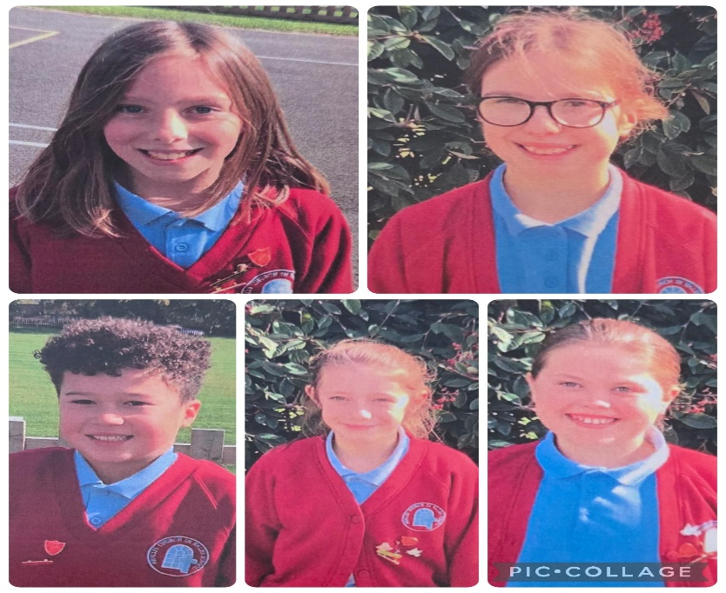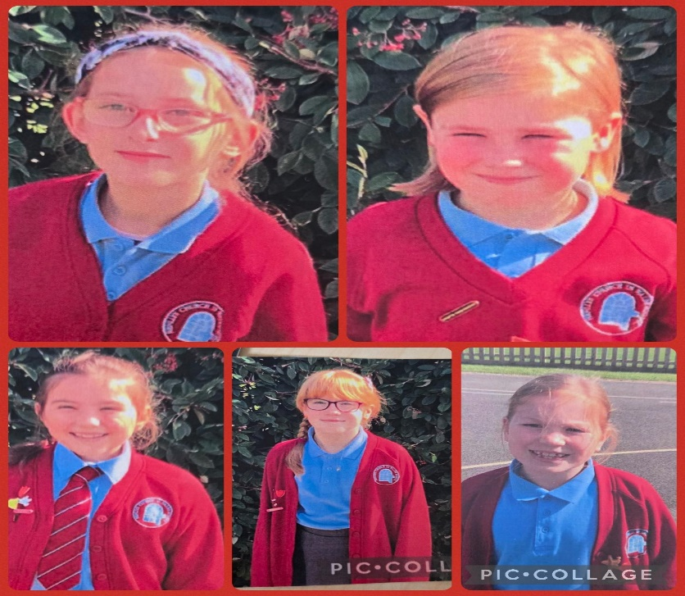

Worship Workers
Our Worship workers have been working really hard this year. Here are some words from our leader Miss Bevan: “Worship workers are trying to sort prayer bears out. On Tuesday bible quotes are printed and given out. We display the Bible quotes in our classrooms. On Tuesday if people bring in prayers to read they can read them at the end of Reverend Kerls worship. We are starting to plan a Bible club session and are starting to prepare for the Harvest Eucharist.”
By Carys Horan. Young Writer. Yr 6

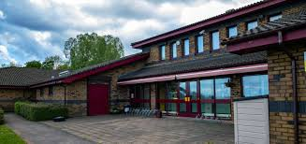
We are very roud of our school and we are excited as young writers to bring pupils and parents news from school written by us.

Friday 10th October 2025 | The Henllys Herald |  |  | Issue #1
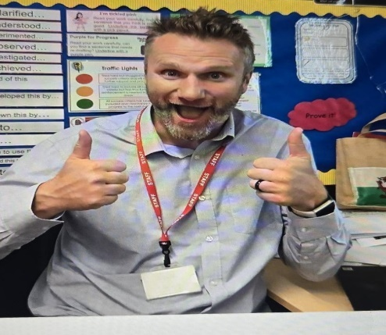
Meet our Deputy Head. An interview with Mr Cleverley.

What have you enjoyed most in your first year at Henllys Church?
All the community is very friendly. The parents, the children and (most of) the staff have been amazing to get to know!
What have you brought with you that helps Henllys to shine? I hope I have brought some fun and enjoyment to my classes. I have definitely brought a spreadsheet!
Tell us three things about you…
I love to travel and have been lucky to see many countries.
I have 3 children, who play lots of sports.
I love the mighty Aston Villa!

By Ivy Priest. Young Writer. Yr 6.
Sports Ambassadors  As sports ambassadors we make sure all pupils in the school stay healthy and fit, we also help to look after sports equipment to be used again and again. We create warm ups and games for younger children and we try to encourage pupils to try new sports. This will help us to make the school a healthier place for all pupils.  By Leo Farrelly, Young Writer. Yr5 |  | Junior Rangers  The Junior Rangers for 2025-2026 have been picked. The Junior Rangers are a group of children who work with Mr Jones and Mrs Meehan to look after the plants in our school. Many of the Junior Rangers were chosen for their participation in school Eco club and for their love of nature. They have recently planted a pear tree and harvested appleas and pears. We will interview Junior Rangers in future issues to share their journey.  By Phoebe Isodoro, Young Writer. Yr 6 and Annabel Oliver, Young Writer. Yr 4 | Digital Leaders  As Digital Leaders we keep people safe online by making them aware of any online dangers and how to avoid them. We make sure the whole school knows how to stay safe online and how important it is. This helps to keep the whole school safe but also allows them to know how to use and enjoy the internet and being online and using technology.  By Louis Carnegie, Young Writer. Yr 5
Librarian News  The Librarians have been chosen and it is our job to keep the library in order and tidy. We attend meetings to discuss future plans for the library. We sometimes have a Librarian from Cwmbran Library come in to help us. We are celebrating at the moment as our school won a trip for having the highest engagement and completion of the Summer Reading Challenge. Da Iawn Pawb!  By Nancy Hackwood, Young Writer. Yr 6  Remember, Remember……  Shwmae day is 15th October – Wear red please!  Show Racism the Red Card 17th October – Wear red please!  Children in Need, 14th November – Theme to be confirmed.  Odd socks day – Anti Bullying 10th November |  |  | Heddlu Bach  Heddlu Bach is a little school Police group who help us to stay safe. They have a uniform to show their role and stand out and they work as a team. They present assemblies about the importance of staying safe in different situations. They also meet with a Police Officer to learn about how the Police force works and why it is so important in our community.  By Anna-Lee Rees, Young Writer, Yr6

